**Lesson09 Azure Resource Management templates (ARM)**

**Notes: -**

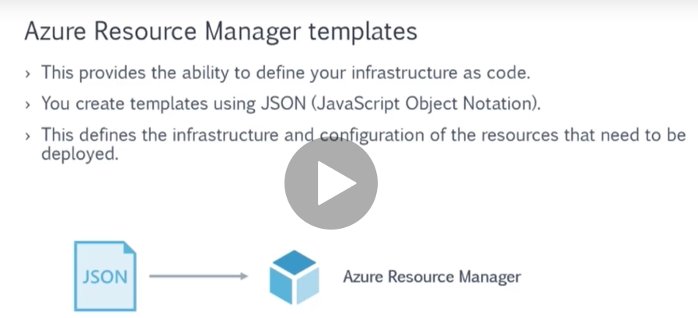

**This JSON contains the configuration of create any resources such as VM, VNET, storage account, etc.**

**(Then you can upload to azure resource manager to execute that JSON)**

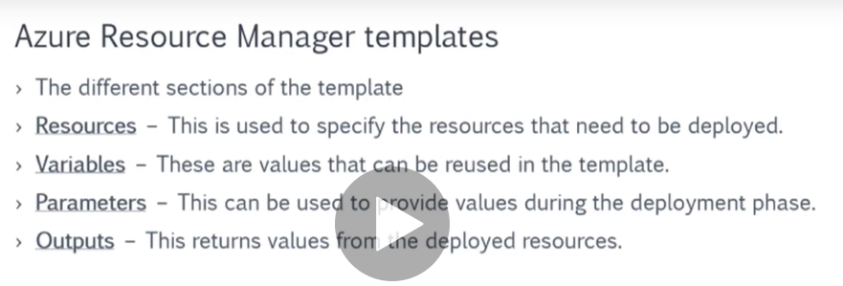

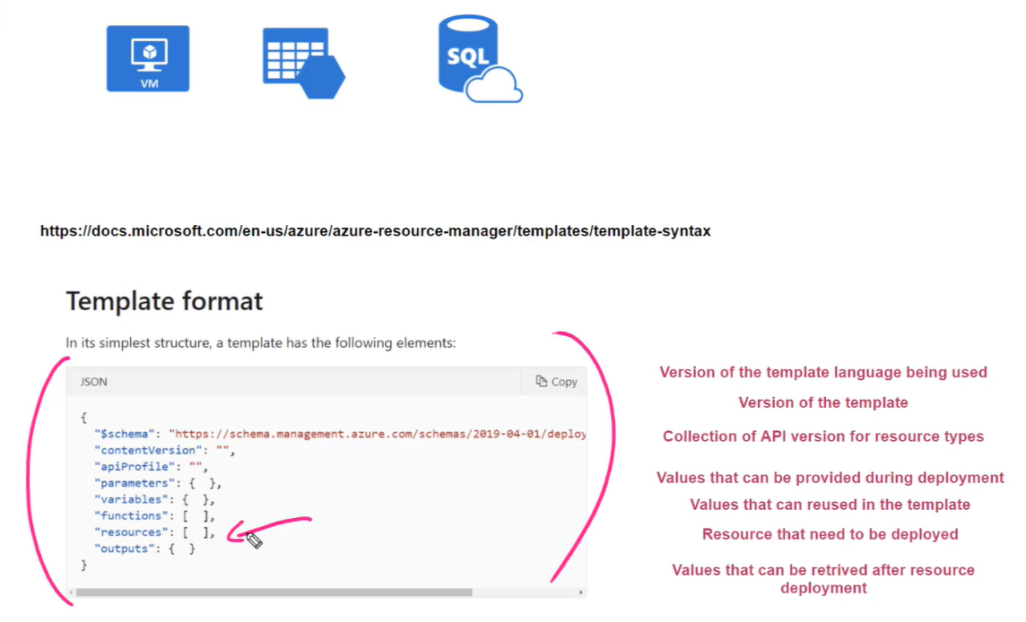

**Steps: -**

**1-on Azure > template deployment > Create windows virtual machine**

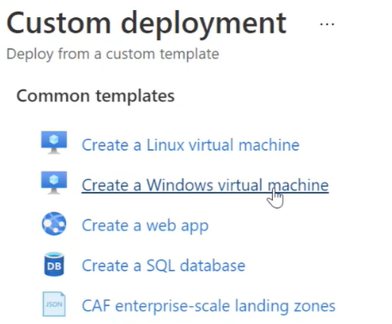

**2-click on Edit template you will see the azure template format that contains all the azure resource information as below**

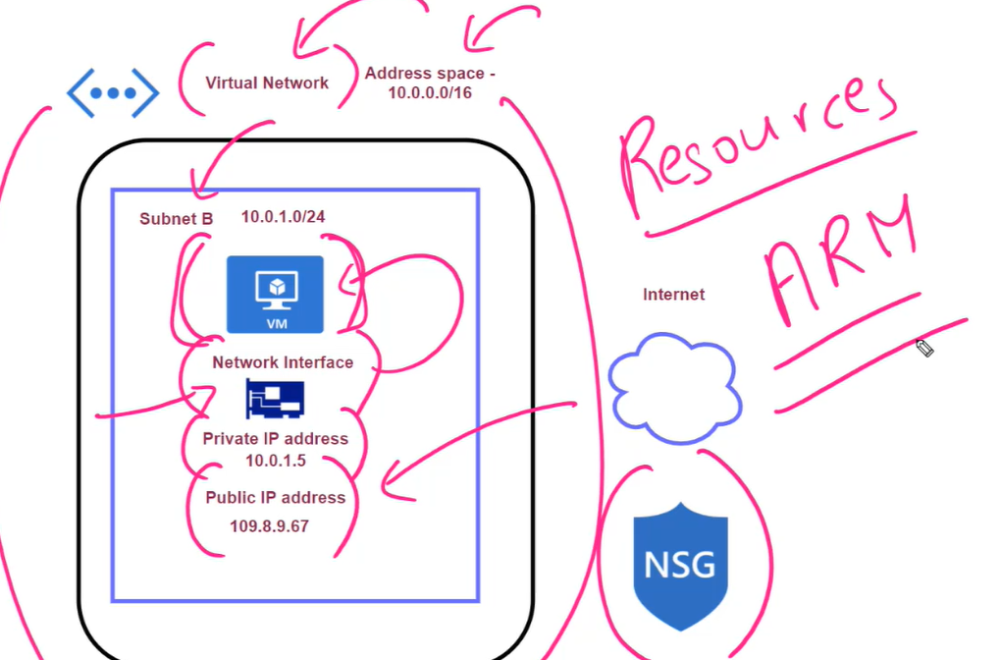

**On Azure Portal > VM > click on the export template option**

**{"$schema": "https://schema.management.azure.com/schemas/2015-01-01/deploymentTemplate.json#",**

**"contentVersion": "1.0.0.0",**

**//it will define the parameters for this Azure VM**

**"parameters": {**

**"virtualMachines_enbeh_vm_name": {"defaultValue": "enbeh-vm","type": "String"},**

**//it will define the parameter of the Azure O.S data disk**

**"disks_enbeh_vm_OsDisk_1_ccad90fc5165463cad854c8145c65381_externalid": {**

**"defaultValue": "/subscriptions/33bdfb9e-064a-41cf-a348-7918aad8b92a/resourceGroups/ENBAH-GROUP/providers/Microsoft.Compute/disks/enbeh-vm_OsDisk_1_ccad90fc5165463cad854c8145c65381","type": "String"},**

**//it will define the parameter of the Azure Network interface**

**"networkInterfaces_enbeh_vm316_externalid": {**

**"defaultValue": "/subscriptions/33bdfb9e-064a-41cf-a348-7918aad8b92a/resourceGroups/enbah-group/providers/Microsoft.Network/networkInterfaces/enbeh-vm316","type": "String"}},**

**//no variable passed**

**"variables": {},**

**"resources": [{**

**"type": "Microsoft.Compute/virtualMachines",**

**"apiVersion": "2019-07-01",**

**//we see that it used the parameter virtualMachines_enbeh_vm_name**

**"name": "[parameters('virtualMachines_enbeh_vm_name')]",**

**//set the location west Europe**

**"location": "westeurope",**

**//define tag for resource as enbeh-vm**

**"tags": {"enbeh-vm": "enbeh-vm"},**

**"properties": {**

**//use VM type of B1ms**

**"hardwareProfile": {"vmSize": "Standard_B1ms"},**

**"storageProfile": {**

**"imageReference": {**

**"publisher": "MicrosoftWindowsServer",**

**"offer": "WindowsServer",**

**"sku": "2019-Datacenter",**

**"version": "latest"},**

**"osDisk": {**

**"osType": "Windows",**

**//pass the O.S data disk to the Azure VM**

**"name": "[concat(parameters('virtualMachines_enbeh_vm_name'), '_OsDisk_1_ccad90fc5165463cad854c8145c65381')]",**

**"createOption": "FromImage",**

**"caching": "ReadWrite",**

**"managedDisk": {**

**"storageAccountType": "StandardSSD_LRS",**

**//pass the Azure VM Data disk as parameter on the managed disk**

**"id": "[parameters('disks_enbeh_vm_OsDisk_1_ccad90fc5165463cad854c8145c65381_externalid')]"},**

**"diskSizeGB": 127},**

**"dataDisks": []},**

**"osProfile": {**

**"computerName": "[parameters('virtualMachines_enbeh_vm_name')]",**

**"adminUsername": "m.enbeh",**

**"windowsConfiguration": {**

**"provisionVMAgent": true,**

**"enableAutomaticUpdates": true},**

**"secrets": [],**

**"allowExtensionOperations": true,**

**"requireGuestProvisionSignal": true},**

**"networkProfile": {**

**"networkInterfaces": [**

**//pass the network interface parameter as the network interface id resource attached with VM**

**{"id": "[parameters('networkInterfaces_enbeh_vm316_externalid')]"}]}}}]}**

**3-the basic information are display on the Azure dashboard and the rest information are displayed on the ARM template**